Tableau Dashboards Documentation

## **1. Analytics Team**

*Team members:* Anh Quan Hua

Xiaolu Li

Gouri Nandan Reddy Gangavaram

Nithini Bogahawattha

## **2. Introduction**

*Definitions*: Tableau Dashboards are condensed views comprised of several visualisations that attempt to assist users in rapidly grasping the primary insights to be displayed. Since our analysis report contains visualizations that might not be easily interpret to a wide range of viewers, our Tableau Dashboards are created to find the market gap and help our company to be more successful.

*Implementation*: Because of the way our datasets are built, it is critical to clean the data before utilising it to eliminate null and misleading data. Also, here I filtered out the list of activities that would be useful for us and for easier understanding and visualizing the no. of calories lost in that particular activity among those weight groups.

*Limitations*: Regardless of our results, Tableau is an excellent tool for creating meaningful infographics. The primary restriction here is first and foremost our team's Tableau competence since certain members only recently began to study and investigate Tableau at the start of the project. The second constraint is that the source data (csv files) retrieved from Kaggle may not be suitable for rapid visualisation in Tableau, necessitating additional analysis/processing.

*Data sources:* Calories Burnt during Exercises & Activities Data:

<https://www.kaggle.com/aadhavvignesh/calories-burned-during-exercise-and-activities>

## **3. Progress Update**

# **a. Data Cleaning & Visualization – Python Programming**

**Data used**: Calories Burnt by 59 Kgs & 93 Kgs after working out for an hour. The number of Calories burnt per kg for that exercise.

**Data Pre-processing:**

The data columns in this table are in lbs, while the calories per kg are in kgs. So, using Python, I changed the columns to kgs for better comprehension and visualisation. If any null values are identified, the data must be cleaned by eliminating the data entries for consistency. Furthermore, activities are filtered based on our company's needs, as not all activities are important to us. The finished dataset is then saved as a csv file and processed in Tableau for additional display.

1. **Importing packages used for data pre-processing:**

Here, all the packages required are imported for further using and the input csv data file is read using the python pandas packages “read_csv()”.

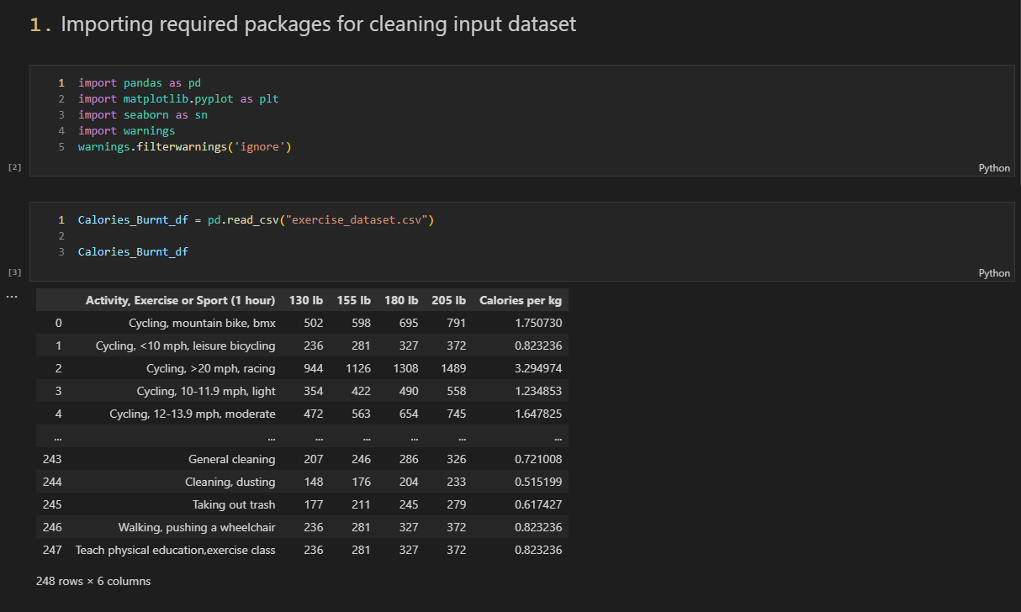

1. **Data Cleaning process:**

Here, the column names are converted from ‘lbs’ to ‘kgs’ for further processing. Then, the data is checked for any Null/NA values as we need to handle them if any found, either by removing that entire row or giving it the mean of the column to keep the integrity of data. Activities are also filtered as per the requirements of our company as below.

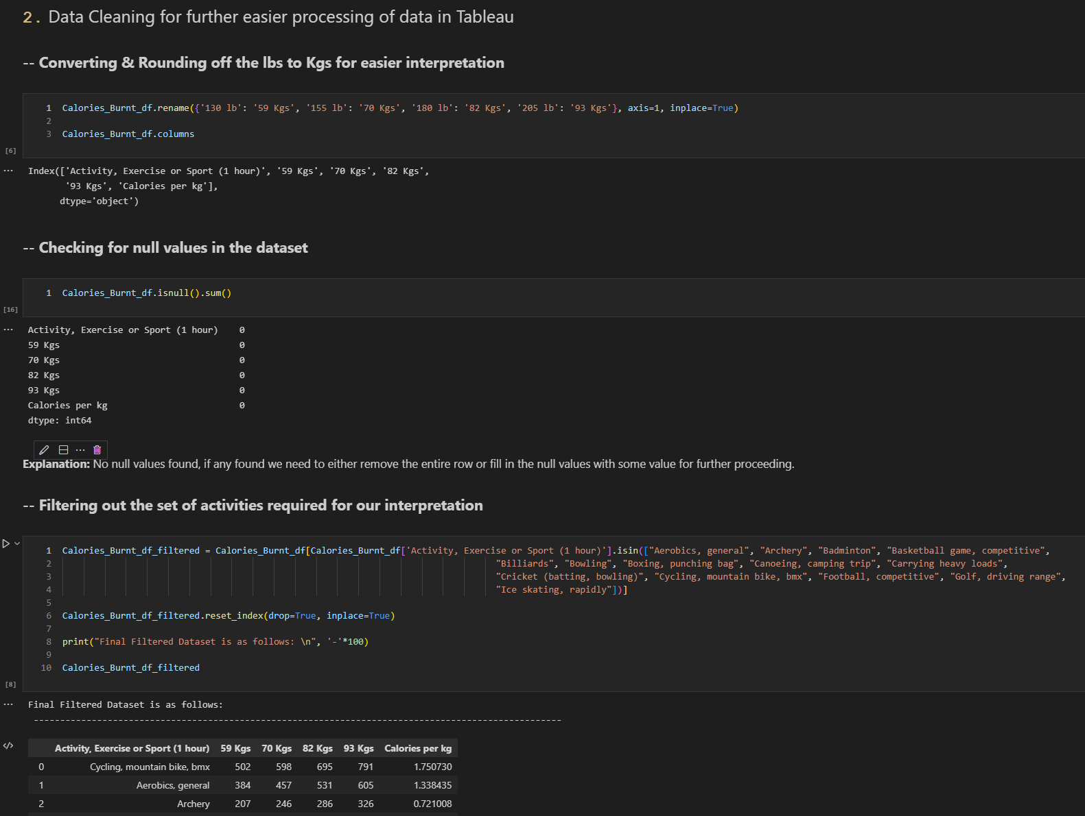

Saving the final csv data into a csv file for that to be imported in Tableau and create visualizations for better understanding of the data for the success of the company.

1. **Data Visualization in Python – Alternative for Tableau:**

Here, using different python packages such as matplotlib & seaborn data can be visualized into different forms of graphs like bar-plot, pie chart, etc.

Above, visualization represents the number of calories lost per kg on an average between different activities, this could be useful for our company, to identify the best set of activities for different weight groups and implement them in our company as a virtual exercising activity for our company’s success.

# **b. Calories Burnt during Exercises – Tableau Dashboard**

**Link to public dashboard:** <https://public.tableau.com/app/profile/gouri.nandan.reddy.gangavaram/viz/FitnessActivities_CaloriesBurnt_Dashboard/Fitness_Weight_Ranges_Dashboard>

**Data used**: Calories Burnt by 59 Kgs & 93 Kgs after working out for an hour. The number of Calories burnt per kg for that exercise.

**Data Pre-processing:**

Here, data columns are in lbs and the calories per kg are in kg. So, using python I converted the columns to Kgs for better understanding and visualization purposes as we need. Data is checked for null values, if any found the data needs to be cleaned by removing the data records for consistency. Also, filtering of the activities is done, as per the requirements of our company as not all activities are relevant for our company. Then the final dataset is stored into a csv file and is further processed in Tableau for further visualization.

**Graph Details:**

*1st Graph:*

The 1st graph illustrates total no. of calories burnt in a hour by a 130lb/59kgs person after doing different activities listed on the x-axis. We can use this analysis to identify the best activity people can perform for losing more calories.

*2nd Graph:*

The 2nd graph illustrates total no. of calories burnt in a hour by a 205lb/93kgs person after doing different activities listed on the x-axis. We can use this analysis to identify the best activity people can perform for losing more calories.

*3rd Graph:*

The 3rd graph illustrates the calories lost /kg for each different activity list below in an hour of performing that said activity overall. This information can be really useful to understand what could possible be the best activity that can be performed for an hour resulting in the most number of calories burnt in an hour.

